**ASSIGNMENT 1 (GETTING START WITH HTML)**

**1) Write a simple program in HTML that displays the heading "HTML defines the content and structure of your website” on the web browser?**

<!DOCTYPE html>

<html lang="en">

<head>

    <meta charset="UTF-8">

    <meta name="viewport" content="width=device-width, initial-scale=1.0">

    <title>Heading</title>

</head>

<body>

    <h1>HTML defines the content and structure of your website.</h1>

    <h2>HTML defines the content and structure of your website.</h2>

    <h3>HTML defines the content and structure of your website.</h3>

    <h4>HTML defines the content and structure of your website.</h4>

    <h5>HTML defines the content and structure of your website.</h5>

    <h6>HTML defines the content and structure of your website.</h6>

</body>

</html>

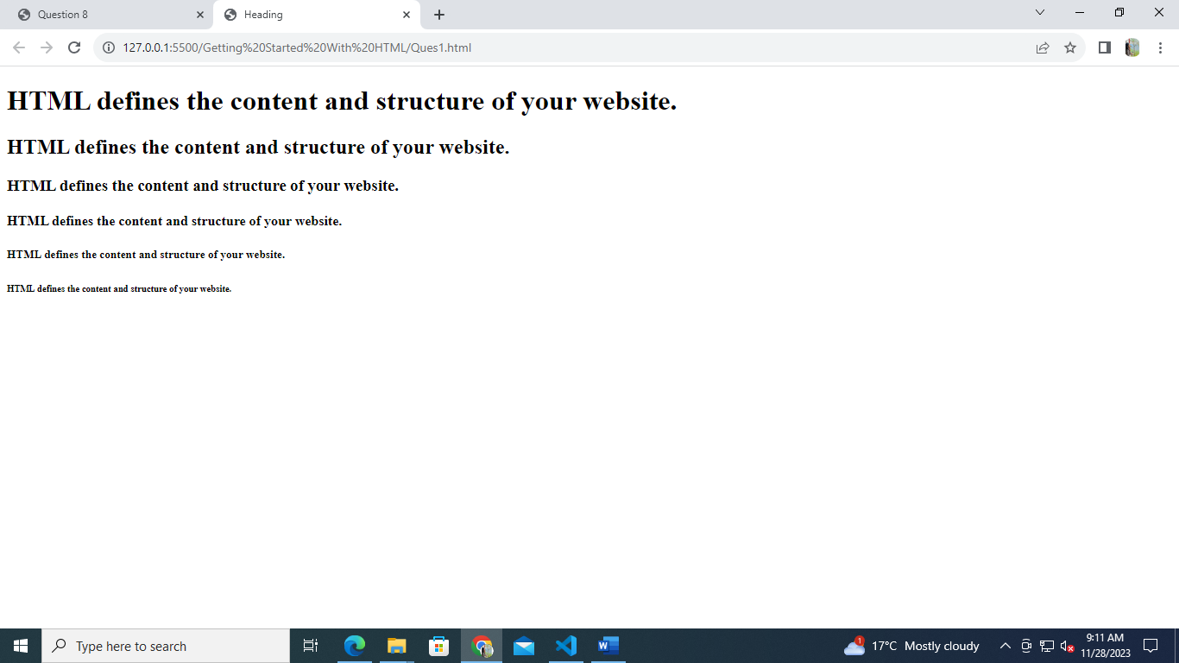**OUTPUT: -**

**2) Explain the purpose of comments in HTML and provide an example of how to use comments in an HTML document?**

HMTL comments are non-rendered text that provide information about code which is visible. They are not displayed in the browser, but they can help document your HTML source code.

Comments of any code make code easy to understand and increase readability of code.

We can add comments in your HTML file using <! -- ... --> tag.

<!DOCTYPE html>

<html lang="en">

<head>

    <meta charset="UTF-8">

    <meta name="viewport" content="width=device-width, initial-scale=1.0">

    <title>Comments</title>

</head>

<body>

     <!-- This is used to explain the comments -->

 <h2>Used of Comment</h2>

 <!--  <p> This line is commented so this will not render on screen. </p>   -->

 <p>This line will render on screen.</p>

</body>

</html>

First comment provide purpose about the heading

* Second comment is used to make paragraph invisible (or to make paragraph not render on screen).

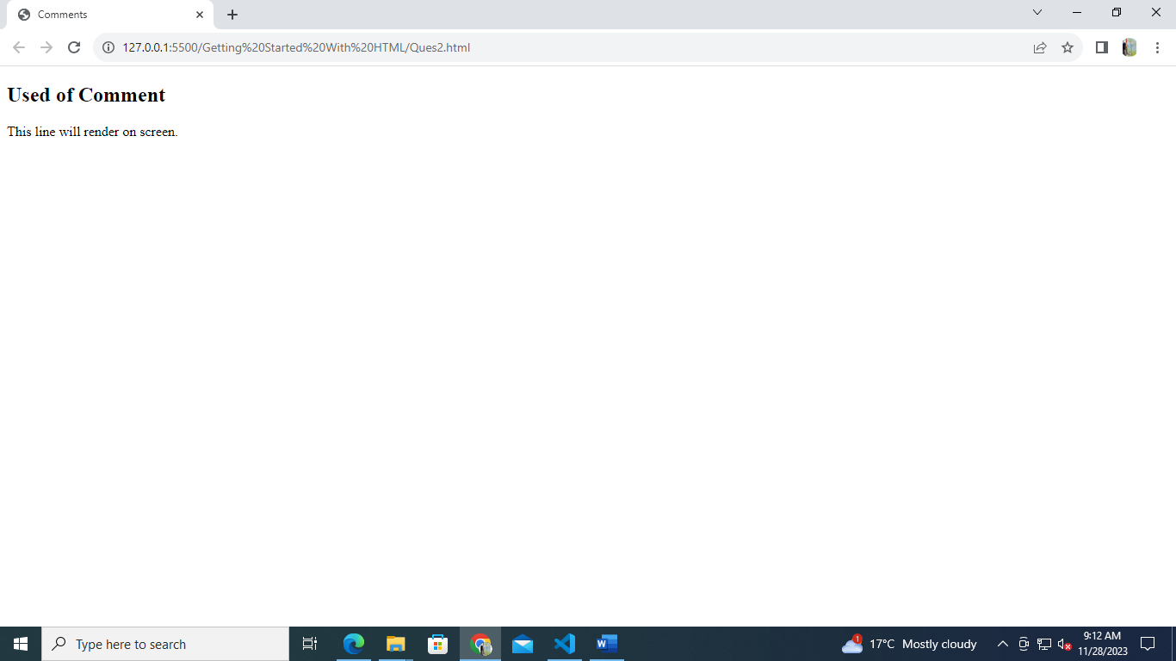**OUTPUT: -**

**3) Write an HTML program that includes a heading, a paragraph of text, a horizontal line, and a line break. Arrange these elements to create a simple web page layout?**

<!DOCTYPE html>

<html lang="en">

<head>

    <meta charset="UTF-8">

    <meta name="viewport" content="width=device-width, initial-scale=1.0">

    <title>Document</title>

</head>

<body>

    <h1>Introduction to HTML</h1>

    <hr>

    <h3>What is HTML?</h3>

    <p>HTML stands for Hyper Text Markup Language.

        <br>HTML is the standard markup language for creating Web pages.

        <br>HTML describes the structure of a Web page.

        <br>HTML consists of a series of elements.

        <br>HTML elements tell the browser how to display the content.

        <br>HTML elements label pieces of content such as "this is a heading", "this is a paragraph", "this is a link", etc.

    </p>

</body>

</html>

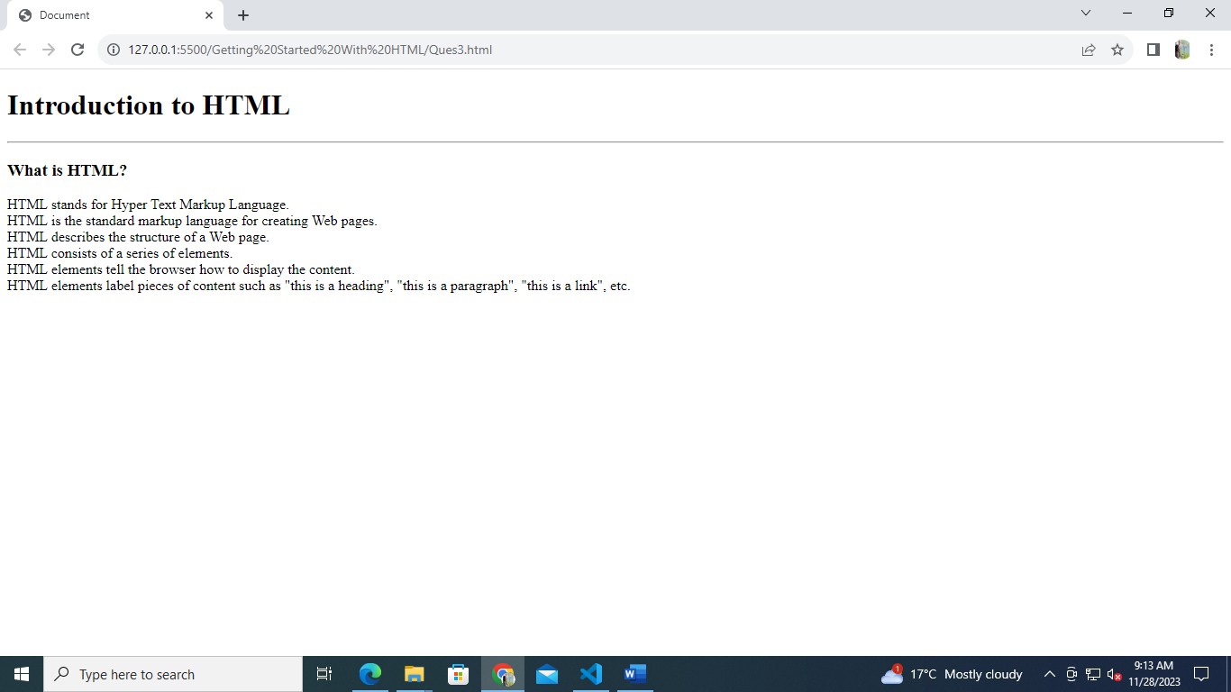**OUTPUT: -**

**4) Write a short note on Tag and element with an example?**

**Tags: -** Tags are the starting and ending parts of an HTML element. They begin with < symbol and end with > symbol. Whatever written inside < and > are called tags. Tags are used to instruct the web browser how to display the content they enclose. Tags are almost like keywords where every single tag has unique meaning.

HTML Tags contain three main parts: opening tag, content and closing tag. But some HTML tags are unclosed tags.

**Syntax: -**

<tag> content </tag>

**Ex: -**

<p> Paragraph Tag </p>

<h2> Heading Tag </h2>

**Elements: -** Elements enclose the contents in between the tags. These elements are responsible for creating web pages and define content in that webpage. They consist of some kind of structure or expression. It generally consists of a start tag, content and an end tag. Elements specifies the general content.

**Ex: -**

<!DOCTYPE html>

<html>

<head>

    <title>Webpage</title>

</head>

<body>

   <h1>This is Heading</h1>

     <p>It looks Nice!!!!!</p>

</body>

</html>

Here <h1> is the opening tag, "This is Heading" is the content, and </h1> is the closing tag.

**5) What is the DOCTYPE Declaration in HTML?**

Ans 5) The HTML document type declaration, also known as DOCTYPE, is the first line of code required in every HTML or XHTML document. It ensures proper rendering and parsing by web browsers. The DOCTYPE declaration is an instruction to the web browser about what version of HTML the page is written in. This ensures that the web page is parsed the same way by different web browsers.